**Project 10: Water Level Indicator**

**Description:**

This simple project aims at indicating the height level of liquid present in a container using a 7-segment display and a microcontroller. Also, a buzzer is activated when the water level is full. The main component used in this project is the **ATMEGA8** microcontroller (PDIP pin configuration). The only constraint is the liquid must be a good conductor of electricity.

ATMEGA8 microcontroller (PDIP pin configuration) is a small, 28 pin electronic device used mainly in control and automation processes. For example, we can use it for measuring the brightness of a light emitting device or in a fire alarm system.

The web link for the project description in detail: [Water Level Indicator](https://www.electronicshub.org/water-level-indicator/)

1. Circuit diagram:

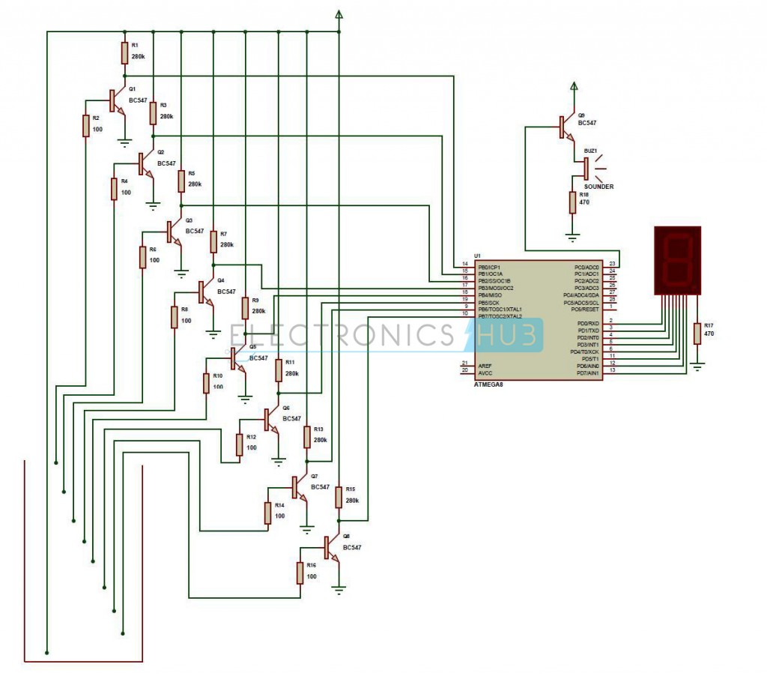

1. Flowchart:

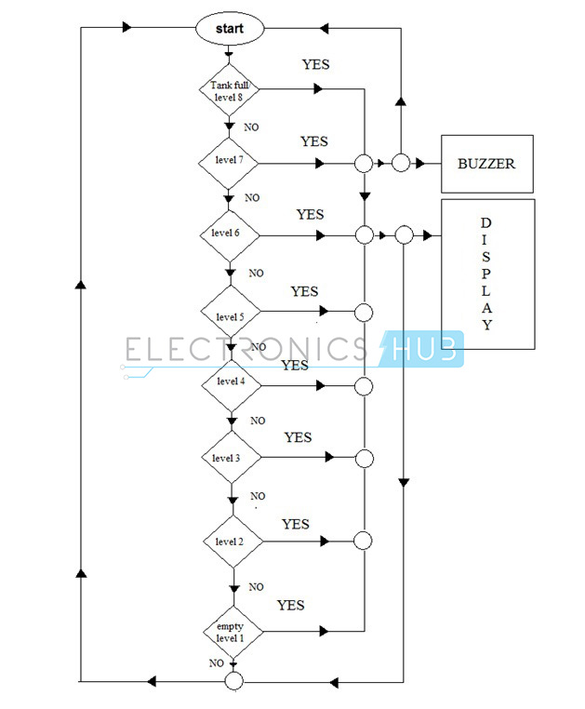

The web link for the info about the ATMEGA8 microcontroller: [AVR Atmega8 Microcontroller Architecture & Its Applications](https://www.elprocus.com/avr-atmega8-microcontroller-architecture-applications/)

The link also contains the configuration about the ports and the various in-built interfaces.

The PDIP pin configuration image:

